**DATA ANALYTICS ASSIGNMENT 5.1 (QUESTION – 2)**

2. Visualize the vowels distribution.

>>area.color <- c("withcolour",NA,NA,NA,"withcolour",NA,NA,NA,"withcolour",

NA,NA,NA,NA,NA,"withcolour",NA,NA,NA,NA,"withcolour",

NA,NA,NA,NA,NA)

area.color

library(ggplot2)

plot.vowel <- ggplot(data = distribution, aes(x=letters, y=Freq, fill=area.color))+

geom_bar(stat = "identity") +

xlab(colnames(distribution)[1]) +

ylab(colnames(distribution)[2])

plot.vowel

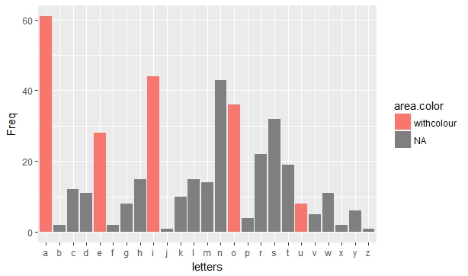

**DATA ANALYTICS ASSIGNMENT 5.2**

Session 5 - Data Management using R Assignment - 2

Problem Statement

1. Obtain the elements of the union between two character vectors.

|  |
| --- |
| vec1<-c(rownames(mtcars[1:15,]))  > vec2<-c(rownames(mtcars[10:32,]))  > vec12<-union(vec1,vec2)  > vec12  [1] "Mazda RX4" "Mazda RX4 Wag" "Datsun 710"  [4] "Hornet 4 Drive" "Hornet Sportabout" "Valiant"  [7] "Duster 360" "Merc 240D" "Merc 230"  [10] "Merc 280" "Merc 280C" "Merc 450SE"  [13] "Merc 450SL" "Merc 450SLC" "Cadillac Fleetwood"  [16] "Lincoln Continental" "Chrysler Imperial" "Fiat 128"  [19] "Honda Civic" "Toyota Corolla" "Toyota Corona"  [22] "Dodge Challenger" "AMC Javelin" "Camaro Z28"  [25] "Pontiac Firebird" "Fiat X1-9" "Porsche 914-2"  [28] "Lotus Europa" "Ford Pantera L" "Ferrari Dino"  [31] "Maserati Bora" "Volvo 142E" |
|  |
| |  | | --- | | > | |
|  |

2. Get those elements that are common to both vectors.

> intersect(vec1,vec2)

[1] "Merc 280" "Merc 280C" "Merc 450SE"

[4] "Merc 450SL" "Merc 450SLC" "Cadillac Fleetwood

3. Get the difference of the elements between two character vectors.

|  |
| --- |
| > setdiff(vec1,vec2)  [1] "Mazda RX4" "Mazda RX4 Wag" "Datsun 710" "Hornet 4 Drive"  [5] "Hornet Sportabout" "Valiant" "Duster 360" "Merc 240D"  [9] "Merc 230"  > setdiff(vec2,vec1)  [1] "Lincoln Continental" "Chrysler Imperial" "Fiat 128"  [4] "Honda Civic" "Toyota Corolla" "Toyota Corona"  [7] "Dodge Challenger" "AMC Javelin" "Camaro Z28"  [10] "Pontiac Firebird" "Fiat X1-9" "Porsche 914-2"  [13] "Lotus Europa" "Ford Pantera L" "Ferrari Dino"  [16] "Maserati Bora" "Volvo 142E" |
|  |
| |  | | --- | | > | |

4. Test the quality of two character vectors.

> vec1 = c(rownames(mtcars[1:15,]))

> vec2 = c(rownames(mtcars[11:25,]))

> identical(vec1,vec2)

[1] FALSE